Q1:

Starting namenodes on [localhost]

ERROR: Attempting to launch hdfs namenode as root

ERROR: but there is no HDFS_NAMENODE_USER defined. Aborting launch.

解决1：

是因为缺少用户定义造成的，所以分别编辑开始和关闭脚本

$ vim sbin/start-dfs.sh

$ vim sbin/stop-dfs.sh

在顶部空白处添加内容：

HDFS_DATANODE_USER=root

HADOOP_SECURE_DN_USER=hdfs

HDFS_NAMENODE_USER=root

HDFS_SECONDARYNAMENODE_USER=root

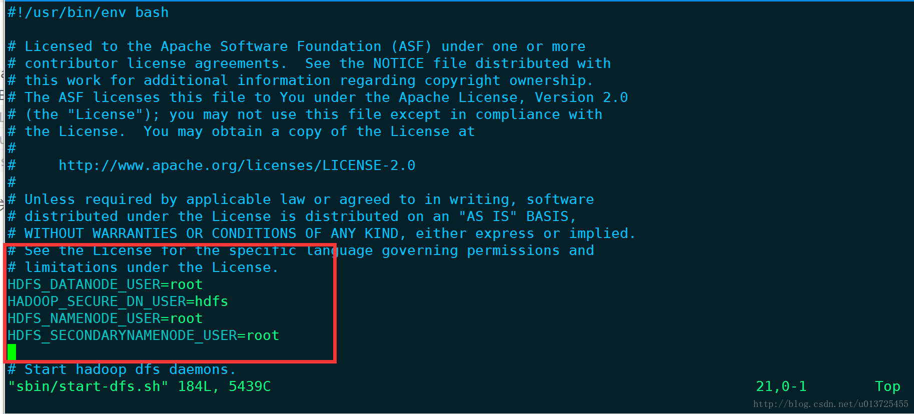

Q2:

Starting resourcemanager

ERROR: Attempting to launch yarn resourcemanager as root

ERROR: but there is no YARN_RESOURCEMANAGER_USER defined. Aborting launch.

Starting nodemanagers

ERROR: Attempting to launch yarn nodemanager as root

ERROR: but there is no YARN_NODEMANAGER_USER defined. Aborting launch.

解决2：

是因为缺少用户定义造成的，所以分别编辑开始和关闭脚本

$ vim sbin/start-yarn.sh

$ vim sbin/stop-yarn.sh

